**Visvesvaraya Technological University, Belagavi**

**Government Engineering College, Mosalehosahalli, Hassan 573201**

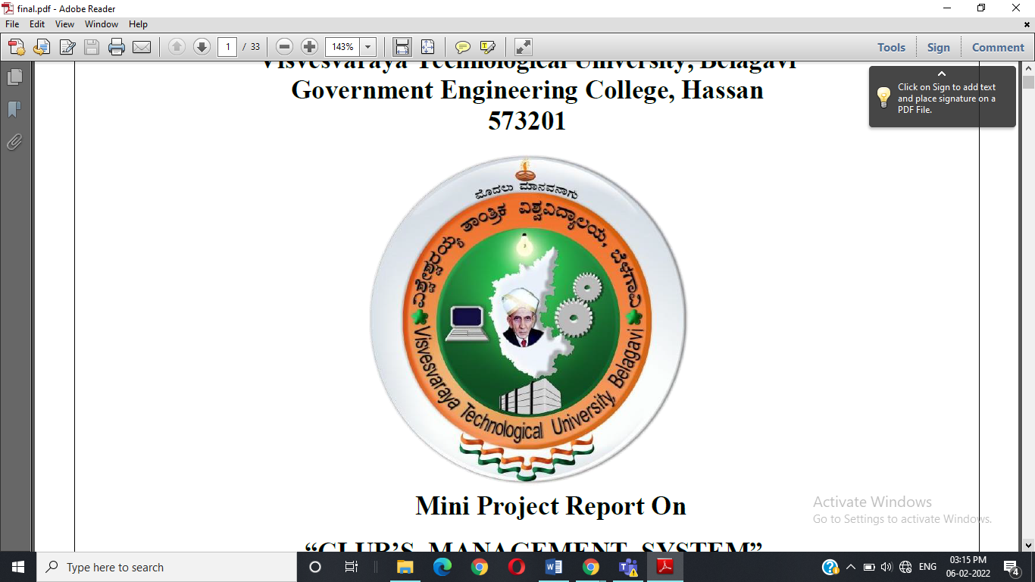

Mini Project Report On

**“COLLEGE WEB SITE DATA AND VERIFICATION SYSTEM”**

Submitted in Partial Fulfillment of Fifth Semester Database Management System Laboratory(18CSL58) in Computer Science & Engineering

**PAVAN .P 4HG19CS028**

**PRIYANKA K.S 4HG20CS410**

**Under the Guidance of**

**Ms. MADHURI H D Dr.Raghu M.E**

**B.E. M.Tech B.E. M.Tech**

Guest lecture Assistant Proffesor

Dept. of CS&E. Dept.of CS&E

Department of Computer Science & Engineering

Government Engineering College, Mosalehosahalli, Hassan-573201

Dec 2021-2022

**DEPARTMENT OF COMPUTER SCIENCE AND ENGINEERING**

**GOVERNMENT ENGINEERING COLLEGE, HASSAN**

**2019-2020**



**CERTIFICATE**

This is to certify that **Mr. PAVAN P USN:4HG19CS028, Ms. PRIYANKA K.S USN:4HG20CS410** has satisfactorily implemented the mini project titled **“COLLEGE WEBSITE MANAGEMENT AND DATA VERIFICATION SYSTEM”** in fifth semester DBMS Laboratory with mini project (18CSL58) as per the requirements of Visvesvaraya Technological University, Belagavi for the academic year 2021-2022..

**GUIDE GUIDE HEAD OF DEPARTMENT**

**Ms. Madhuri H.D Dr. K.C RAVI SHANKAR**

B.E, M.Tech**.**  B.E, M.Tech, PhD

Dept. Of CS&E. Head of department

GECM, Hassan Dept. Of CS&E.

GECM, Hassan.

**External viva**

**Name of the Examiners Signature with date**

1.

2.

**ACKNOWLEDGEMENT**

The completion of any project involves the efforts of many people. We have been lucky to have received a lot of help, support from all directions during making of this project, so with the gratitude we take this opportunity to acknowledge all those who guide and encouraged us.

We are extremely grateful to our principal **Dr. RANGASWAMY** , B.E, M.Tech, Ph.D. for cresting an excellent and technically sound environment in our institution.

We would like to express our profound sense of gratitude to our department HOD **Dr. K.C. Ravi Shankar** , B.E, M.Tech, Ph.D and our guide **Dr.Raghu** , B.E, M.Tech,Ph.D. Dept.of CS&E for their guidance. It’s a great pleasure to acknowledge our sincere gratitude to **Ms.Madhuri H D**, B.E, M.Tech, Dept. of CS&E for their help and encouragement rendered towards the successful completion of the mini project work.

Project Associates

Pavan p

Priyanka K.S

**DECLARATION**

We, Pavan P, Priyanka K S, students of 5th semester B.E, CS&E, Government Engineering College, USN 4HG19CS028, 4HG20CS410 hereby declare that the project entitled “**COLLEGE** **WEBSITE AND DATA VERFICATION SYSTEM**” has been carried out by us under the supervision of **Ms.Madhuri**, professor, Dept of CS&E submitted in partial fulfilment of the requirements for the award of the degree of computer science and engineering by the Visvesvaraya technological university during the academic year 2021-22.This report has not been submitted to any other organization/university for any award of degree certificate.

By:

PAVAN. P

PRIYANKA K. S

**ABSTRACT**

The purpose of the college website and data verification system is to automate the existing manual system by the help of computerized equipment and fully fledged computer software, fulfilling their requirements, so that their valuable information can be stored for the longer period with easy accessing. College website and data verification system as described above can lead to error free, secure, reliable and fast management system.

It can assist the user to concentrate on the record keeping. Thus it helps the organization or institutions in better utilization of the resources. The organization or institutions can maintain computerized records without any redundant entries. That means that one need not be distracted by information that is not relevant.

**CONTENTS**

**Acknowledgement i**

**Declaration ii**

**Abstract iii**

**Chapters**

**1. Overview**

Introduction

Objectives

Proposed system advantages

Scope of the project

Advantages

**2. Requirements Specification**

Functional Requirements

Non Functional Requirements

System Requirements

Hardware Specification

Software Specification

**3. System Design**

System Design Diagram

ER Diagram

Database schema

**4. Implementation**

Tools Used

HTML

CSS

MySQL

PHP

Modules

**5. Interpretation of results**

Conclusion

Reference

**CHAPTER 1**

**OVERVIEW**

**INTRODUCTION**

This project entitled with College website and data verification System. This site developed using HTML and CSS as front end and backend is MYSQL.

With the advance in time and technology there is a need for faster dissemination of information. Many manual processes are being automated. The backend will be updated by the College administrator.College management system can make the work easier for College administrator by providing well structured backend to update the server with current happenings and future updates of the College to Student. The Fronted is also structured in such a way that each and every student gets it easy to use the website.

**OBJECTIVES**

 To develop the well-designed database to store college information.

 Provides full functional report for the system of the college website’s.

 The objective of this project is to provide a comprehensive approach towards the management of the college management.

 Provides the searching facilities based on various branches details such as CS&E,E&C,CIVIL,E&E.

 It tracks all the information of college and student, like logins, data verification.

**PROPOSED SYSTEM ADVANTAGES**

Easy retrieval of information.

Better look and feel.

Easy to manage the entire system

Maintains details of members like the club joined, when they joined etc.

**SCOPE OF THE PROJECT**

One of the most important steps in the process of development of the system is to have a well defined scope of the system. The scope of the system sets down the boundaries and areas covered by the system.  

We can add, update and delete all the new as well as existing records.

The system is user friendly and maintenance of the information is easy.

To minimize the time.

To data entry and make data access possible.

**ADVANTAGES**

Provides computerized system for maintaining records.

More efficient and reliable.

Less time consuming and easy to use.

Avoids data inconsistency and redundancy.

Avoids paper wastage.

**CHAPTER 2**

**SYSTEM REQUIREMENT SPECIFICATION**

**SYSTEM REQUIREMENTS:**

System requirement are expressed in software requirement document. It is the official statement for what is required for the system developers. Requirement document includes the requirement definitions and the requirement specifications.

The software requirement document is not designed document. It should set out what the system should do without specifying how it should be done.

* Storing the information of the college ,student in the customized database
* Accessing information of the member
* Making queries for adding and searching member details

**HARDWARE REQUIREMENTS**

Processor : 2GHz Intel core processor

RAM : 4GB or more

Hard-Disc : 100GB or more

**SOFTWARE REQUIREMENTS**

Operating system : Linux(Ubuntu)/Windows

Language : HTML,CSS,PHP

Database : MySQL

Tools : Sublime Text, Atom, Bracket

Server : Apache2

**CHAPTER 3**

**SYSTEM DESIGN**

**3.1. SYSTEM DESIGN DIAGRAM**

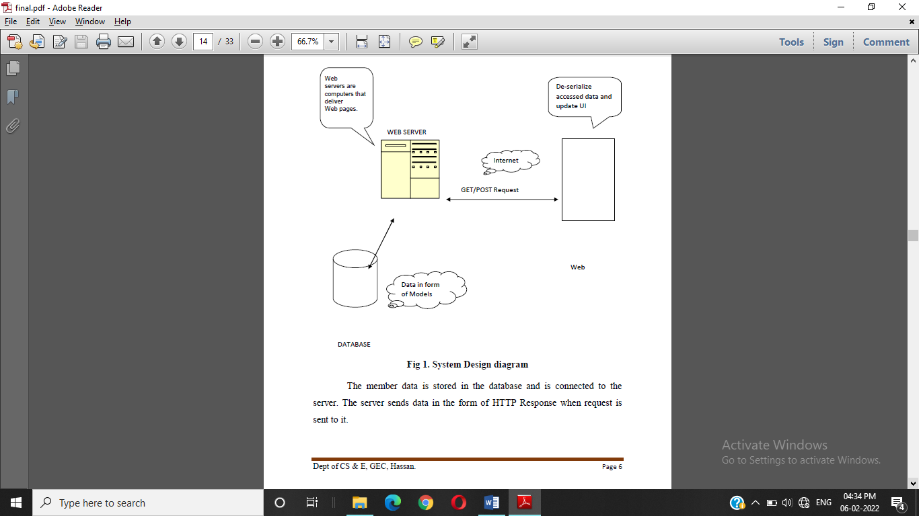

**Fig 1. System Design diagram**

The member data is stored in the database and is connected to the server. The server sends data in the form of HTTP Response when request is send to it.

**3.2. E R DIAGRAM**

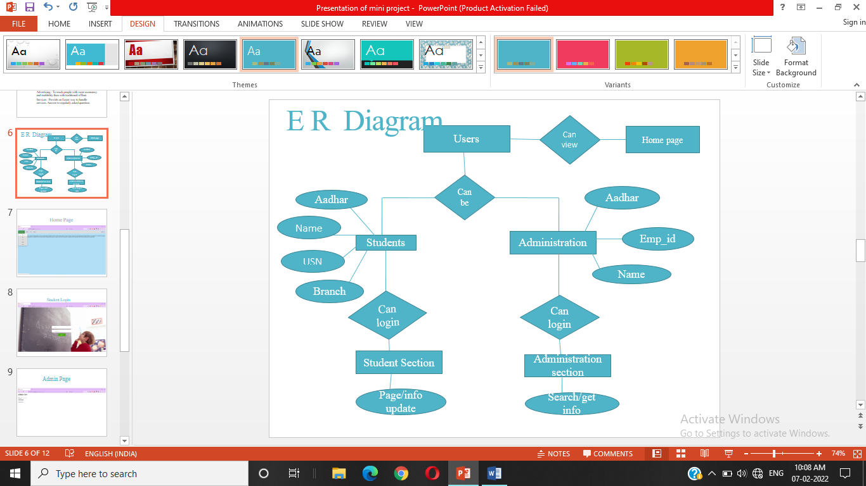

**Fig 2. ER Diagram**

ER diagram is a visual representation of data that describes how data are related to each other. ER diagrams are essential to modelling anything from simple to complex database .There are 4 entities defined namely Student, Administration, Student section,Administration section. Each entity is having relation among one another as show in the Fig 2. The attributes are represented in circles.

**CHAPTER 4**

**IMPLEMENTATION**

The process of putting our plan into execution is said to be as implementation. This implementation process can vary from organisation to another organisation.It is a process that convert strategies and plans into actions to reach required goal.

**TOOLS USED**

**HTML**

Web browsers receive HTML documents from a web server or local storage and render the documents into multimedia web pages.HTML describes the structure of a web page semantically and originally included cues for the appearance of the document.HTML elements are the building blocks of HTML pages.

**CSS**

CSS is designed to enable the separation of presentation and content, including layout, colors and fonts. This separation can improve content accessibility, provide more flexibility and control in the specification of presentation characteristics, and enable multiple web pages to share formatting by specifying the relevant CSS in a separate css file.

**MYSQL**

It is an open source relational database management system. The MySQL development project has made its source code available under the terms of the GNU General Public License, as well as under the variety of proprietary agreements. MySQL was owned and sponsored by a single for profit firm, the Swedish company MySQL AB, now owned by Oracle Corporation.

**PHP**

PHP is a widely-used open source general-purpose scripting language that is especially suited for web development and can be embedded into HTML.

**MODULES**

**CHAPTER 5**

**INTERPRETATION OF RESULTS**

**SNAPSHOTS**

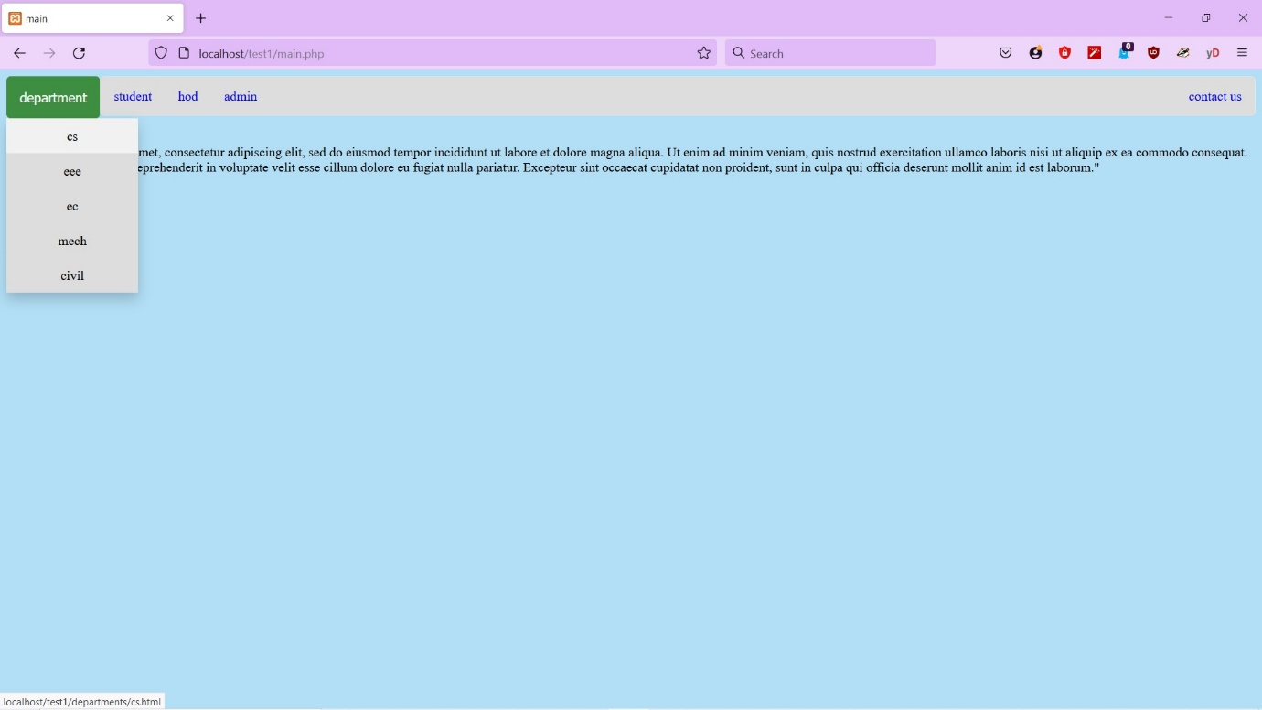

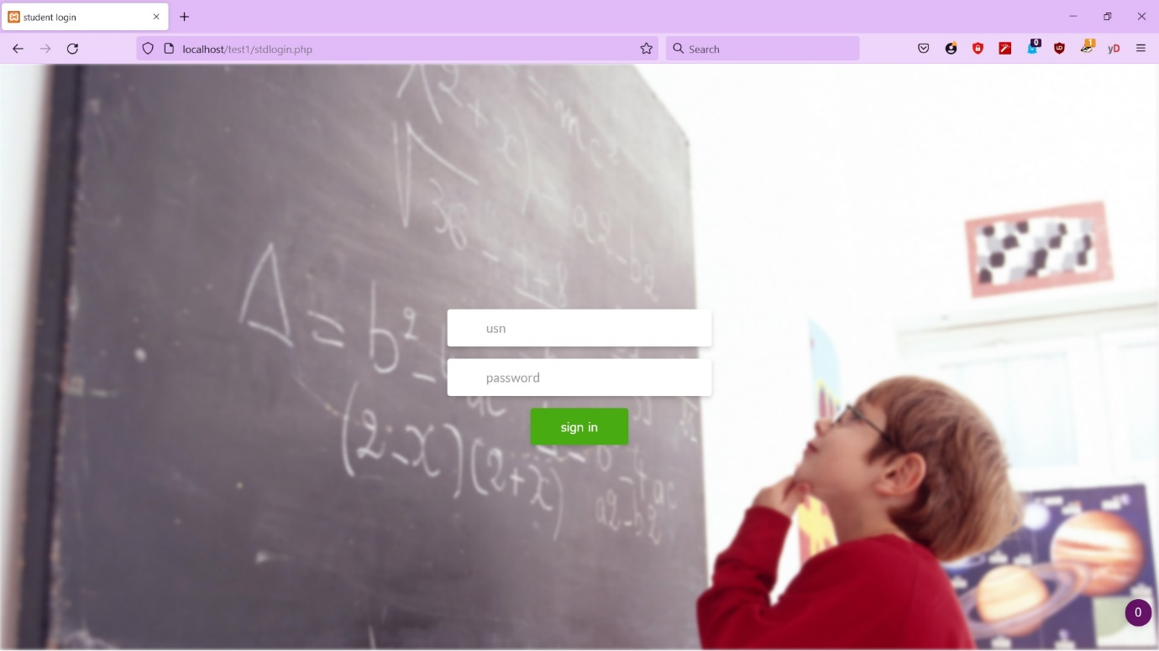

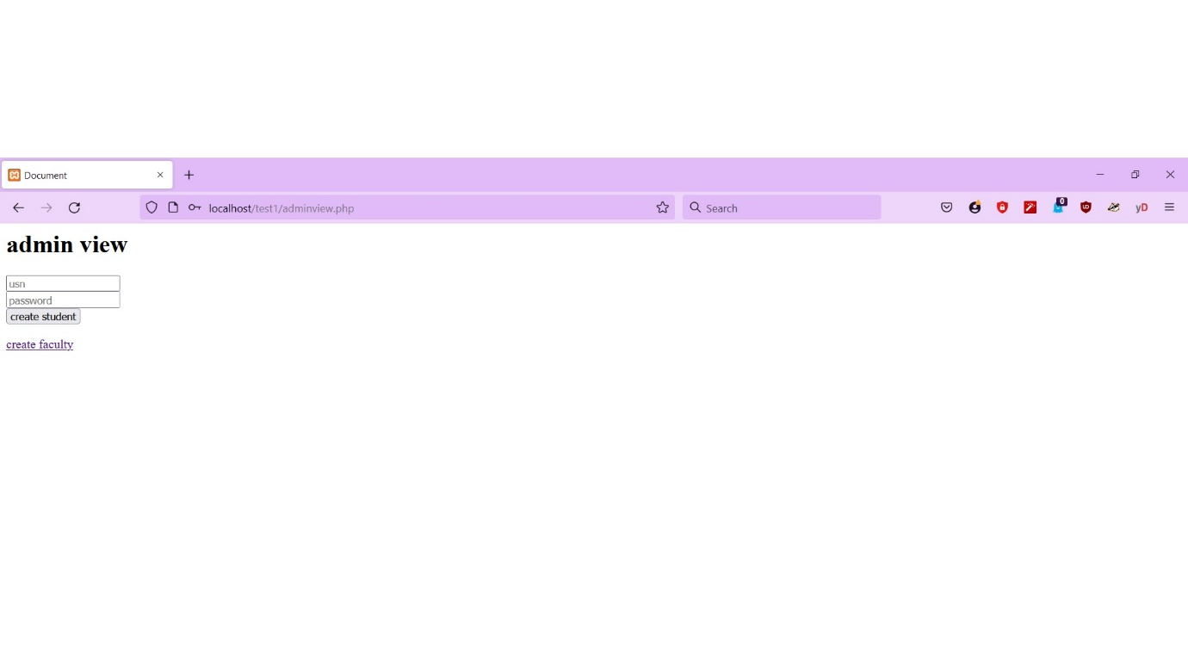

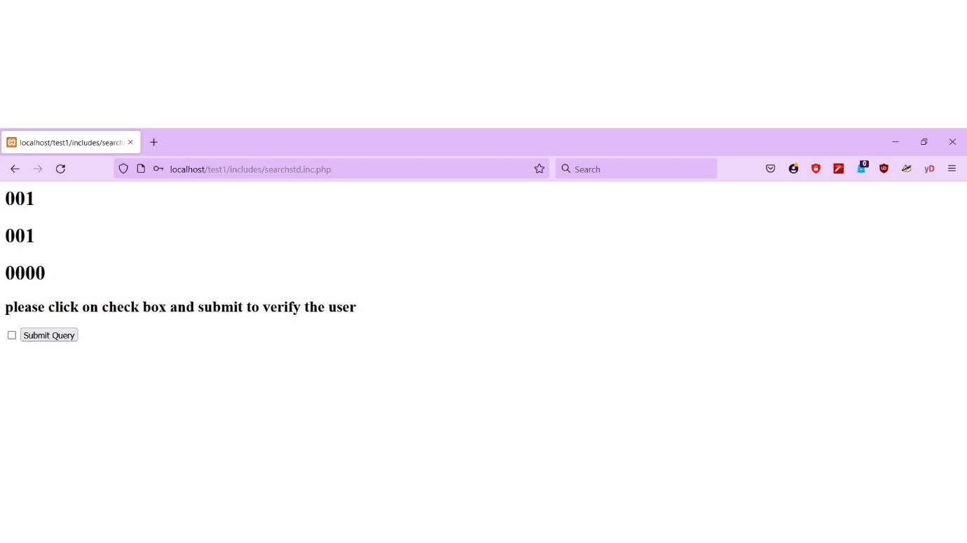

**CONCLUSION**

To conclude the description about the project: the project College website and data verification System has been designed and developed according to the current requirements of a college. College website and data verification System is made for a quick access to accurate data and to help the college admin achieve their goals. College website can be very useful in an organization or institution. It creates an impact on the organization’s performance, functions.

**References:**

* **Fundamental of database system(7th Edition)-**
* [**https://www.w3schools.com**](https://www.w3schools.com)
* [**https://stackoverflow.com**](https://stackoverflow.com)
* [**https://github.com**](https://github.com)
* [**https://www.google.com**](https://www.google.com)
* [**https://www.youtube.com**](https://www.youtube.com)